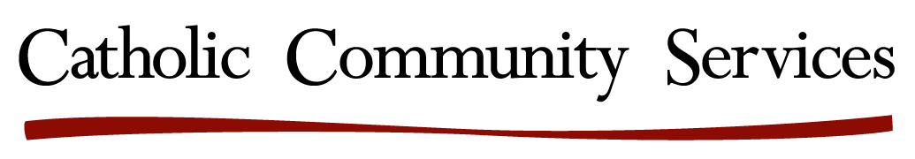

BUILDING COMMUNITY RESILIENCE IN AFFORDABLE HOUSING MINI GRANTS

ROUND ONE APPLICATION DEADLINE: April 15, 2021, 5:00pm PST

Submit Applications to: jsorensen@ccswv.org

Purpose: To improve health outcomes and build community resilience through trauma-informed, collective impact services and community engagement.

Funding Range: $2,500-$10,000:

Who can apply: Local nonprofits and informal groups of concerned community members within specified affordable housing communities and FHI’s eight neighborhood service areas.

Service Areas: Elementary School Catchment Neighborhoods: Auburn Elementary, Salem; Hallman Elementary, Salem; Swegle Elementary, Salem; Washington Elementary, Salem; Independence Elementary, Independence; Nellie Muir Elementary, Woodburn; Washington Elementary, Woodburn.
Affordable Housing Complexes: Casa Adele, Mount Angel; East State Street Apartments, Salem; Mill Creek Apartments, Salem; Renaissance Place, Salem; St. Monica Apartments, Keizer; Villa Esperanza Apartments, Woodburn.

Application Criteria: Successful applications will have measurable outcomes and achieve one or more of the following:
- Help address social, economic and environmental obstacles to healthcare parity,
- Promote health and wellness within a specified, supportive community,
- Demonstrate partnership with local service providers and school districts,
- Demonstrate a strong neighborhood voice in choosing project activities,
- Promote the Five Strengthening Families Protective Factors.™

Project Examples: All community-initiated projects that create social and physical environments that promote good health and wellbeing for all will be considered. These may be projects that promote quality of life, healthy development, and healthy behaviors across all life stages. Example projects may include virtual “ask an expert” resource forums with breakout rooms, a neighborhood mural to transform an eyesore conceptualized by community members and guided by a local artist or a distance learning/business office station with computer set up in an accessible, reservable community room.

BUILDING COMMUNITY RESILIENCE IN AFFORDABLE HOUSING MINI GRANT

APPLICANT INFORMATION:

Organization, Neighborhood or Residential Community Name:

Organization Website:

(if applicable)

Mailing Address:

Application Contact Person / Title:

Phone Number:

Email:
Amount Requested:

Project Start Date:
Project End Date:

PROJECT DETAILS:
Organization mission and primary activities, or for community-driven proposals, the name of a supporting organization that will help guide the project.
Describe the key elements of your project: how it addresses community resilience and positive health outcomes, and the number of people who will benefit.

Please summarize target outcomes and how you will measure success.

Please describe the community/communities that will be served, and the ways that you will engage with them in accessing or carrying out the project. Please explain the extent to which your activities will impact those who have experienced barriers to care and/or services.

Please explain your ability to carry out the project within COVID-19 social distance protocols. This may include virtual events, on-site, social distanced events…

Include a brief budget outlining how grant dollars will be spent.

Please attach one or more of the following documents to your application:

_____Short bio for project leader
_____Neighborhood group description/charter
_____Board of Directors (if applicable)
_____ 501(c)3 letter (if applicable)

